**Current Design: 16 bacteria, evenness between 0.4 and 0.85.**

**Proposal Design: 10 bacteria, evnness between 0 and 1**

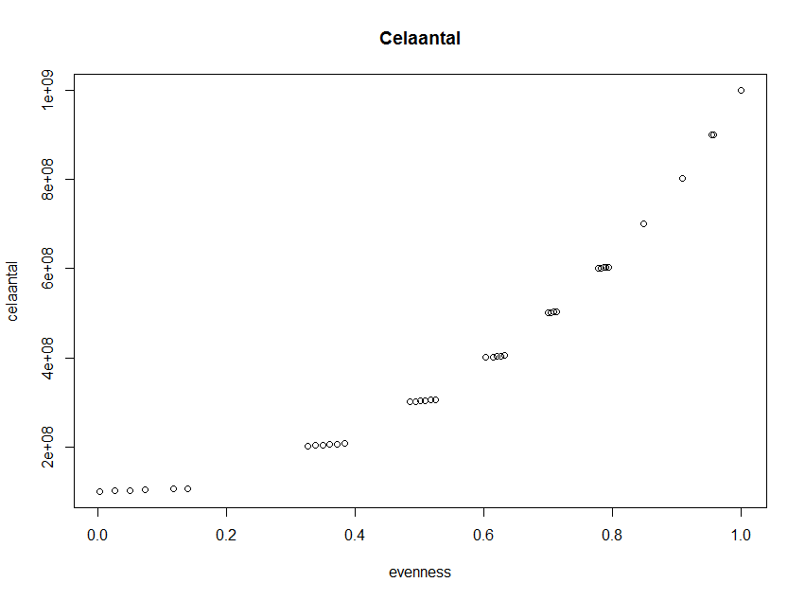

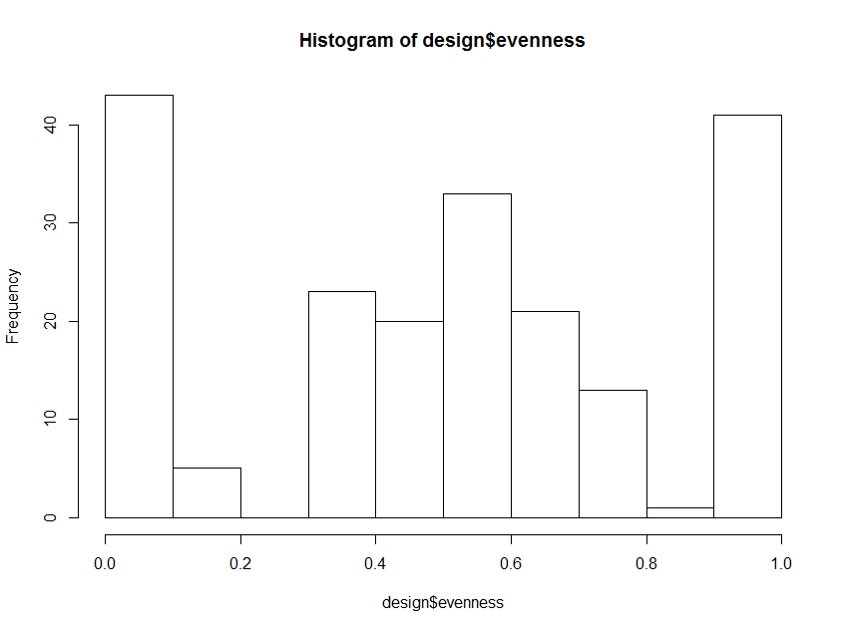

**Redenering**

100 points randomly distributed

100 points according to a certain stratification: 40 low evenness, 40 high evenness, 20 around 0.5 evenness.

|  |
| --- |
| **colour code** |
| 1.00E+04 |
| 1.00E+06 |
| 1.00E+08 |

**pipetting example random evenness**

|  |  |  |  |  |  |  |  |  |  |  |
| --- | --- | --- | --- | --- | --- | --- | --- | --- | --- | --- |
|  | b1 | b2 | b3 | b4 | b5 | b6 | b7 | b8 | b9 | b10 |
| 1 | 1.00E+08 | 1.00E+08 | 1.00E+06 | 1.00E+08 | 1.00E+06 | 1.00E+06 | 1.00E+04 | 1.00E+06 | 1.00E+06 | 1.00E+08 |
| 2 | 1.00E+06 | 1.00E+04 | 1.00E+08 | 1.00E+06 | 1.00E+04 | 1.00E+04 | 1.00E+08 | 1.00E+06 | 1.00E+06 | 1.00E+04 |
| 3 | 1.00E+06 | 1.00E+04 | 1.00E+06 | 1.00E+04 | 1.00E+06 | 1.00E+08 | 1.00E+04 | 1.00E+04 | 1.00E+06 | 1.00E+08 |
| 4 | 1.00E+06 | 1.00E+04 | 1.00E+06 | 1.00E+04 | 1.00E+04 | 1.00E+04 | 1.00E+08 | 1.00E+06 | 1.00E+04 | 1.00E+08 |
| 5 | 1.00E+08 | 1.00E+04 | 1.00E+04 | 1.00E+04 | 1.00E+06 | 1.00E+06 | 1.00E+04 | 1.00E+04 | 1.00E+08 | 1.00E+08 |
| 6 | 1.00E+08 | 1.00E+08 | 1.00E+08 | 1.00E+08 | 1.00E+06 | 1.00E+08 | 1.00E+08 | 1.00E+08 | 1.00E+06 | 1.00E+08 |
| 7 | 1.00E+06 | 1.00E+06 | 1.00E+04 | 1.00E+04 | 1.00E+06 | 1.00E+06 | 1.00E+06 | 1.00E+06 | 1.00E+08 | 1.00E+04 |
| 8 | 1.00E+06 | 1.00E+08 | 1.00E+06 | 1.00E+04 | 1.00E+06 | 1.00E+06 | 1.00E+04 | 1.00E+04 | 1.00E+04 | 1.00E+08 |
| 9 | 1.00E+06 | 1.00E+06 | 1.00E+04 | 1.00E+04 | 1.00E+08 | 1.00E+06 | 1.00E+04 | 1.00E+08 | 1.00E+08 | 1.00E+04 |
| 10 | 1.00E+04 | 1.00E+08 | 1.00E+06 | 1.00E+06 | 1.00E+04 | 1.00E+06 | 1.00E+06 | 1.00E+08 | 1.00E+08 | 1.00E+04 |
| 11 | 1.00E+08 | 1.00E+06 | 1.00E+08 | 1.00E+06 | 1.00E+06 | 1.00E+04 | 1.00E+04 | 1.00E+04 | 1.00E+08 | 1.00E+06 |
| 12 | 1.00E+04 | 1.00E+04 | 1.00E+08 | 1.00E+08 | 1.00E+04 | 1.00E+08 | 1.00E+04 | 1.00E+04 | 1.00E+08 | 1.00E+04 |
| 13 | 1.00E+06 | 1.00E+06 | 1.00E+06 | 1.00E+06 | 1.00E+06 | 1.00E+08 | 1.00E+04 | 1.00E+04 | 1.00E+06 | 1.00E+08 |

**pipetting example low evenness**

|  |  |  |  |  |  |  |  |  |  |  |
| --- | --- | --- | --- | --- | --- | --- | --- | --- | --- | --- |
| 100 | 1.00E+06 | 1.00E+06 | 1.00E+04 | 1.00E+04 | 1.00E+08 | 1.00E+04 | 1.00E+04 | 1.00E+04 | 1.00E+04 | 1.00E+08 |
| 101 | 1.00E+04 | 1.00E+04 | 1.00E+04 | 1.00E+04 | 1.00E+04 | 1.00E+08 | 1.00E+04 | 1.00E+04 | 1.00E+04 | 1.00E+04 |
| 102 | 1.00E+04 | 1.00E+08 | 1.00E+04 | 1.00E+04 | 1.00E+04 | 1.00E+04 | 1.00E+04 | 1.00E+04 | 1.00E+04 | 1.00E+04 |
| 103 | 1.00E+04 | 1.00E+04 | 1.00E+04 | 1.00E+08 | 1.00E+04 | 1.00E+04 | 1.00E+04 | 1.00E+04 | 1.00E+04 | 1.00E+04 |
| 104 | 1.00E+04 | 1.00E+04 | 1.00E+04 | 1.00E+04 | 1.00E+04 | 1.00E+04 | 1.00E+08 | 1.00E+04 | 1.00E+04 | 1.00E+04 |
| 105 | 1.00E+04 | 1.00E+04 | 1.00E+04 | 1.00E+04 | 1.00E+04 | 1.00E+04 | 1.00E+04 | 1.00E+04 | 1.00E+08 | 1.00E+04 |
| 106 | 1.00E+08 | 1.00E+04 | 1.00E+04 | 1.00E+04 | 1.00E+04 | 1.00E+04 | 1.00E+04 | 1.00E+04 | 1.00E+04 | 1.00E+04 |
| 107 | 1.00E+04 | 1.00E+04 | 1.00E+08 | 1.00E+04 | 1.00E+04 | 1.00E+04 | 1.00E+04 | 1.00E+04 | 1.00E+04 | 1.00E+04 |
| 108 | 1.00E+04 | 1.00E+04 | 1.00E+04 | 1.00E+04 | 1.00E+08 | 1.00E+04 | 1.00E+04 | 1.00E+04 | 1.00E+04 | 1.00E+04 |
| 109 | 1.00E+04 | 1.00E+04 | 1.00E+08 | 1.00E+04 | 1.00E+04 | 1.00E+04 | 1.00E+04 | 1.00E+04 | 1.00E+04 | 1.00E+06 |

**pipetting example high evenness**

|  |  |  |  |  |  |  |  |  |  |  |
| --- | --- | --- | --- | --- | --- | --- | --- | --- | --- | --- |
| 141 | 1.00E+08 | 1.00E+06 | 1.00E+08 | 1.00E+08 | 1.00E+08 | 1.00E+06 | 1.00E+08 | 1.00E+08 | 1.00E+08 | 1.00E+08 |
| 142 | 1.00E+08 | 1.00E+08 | 1.00E+06 | 1.00E+08 | 1.00E+06 | 1.00E+08 | 1.00E+08 | 1.00E+08 | 1.00E+08 | 1.00E+08 |
| 143 | 1.00E+08 | 1.00E+08 | 1.00E+08 | 1.00E+08 | 1.00E+06 | 1.00E+08 | 1.00E+06 | 1.00E+08 | 1.00E+08 | 1.00E+08 |
| 144 | 1.00E+06 | 1.00E+08 | 1.00E+06 | 1.00E+08 | 1.00E+08 | 1.00E+08 | 1.00E+08 | 1.00E+08 | 1.00E+08 | 1.00E+08 |
| 145 | 1.00E+08 | 1.00E+08 | 1.00E+08 | 1.00E+06 | 1.00E+08 | 1.00E+08 | 1.00E+08 | 1.00E+08 | 1.00E+08 | 1.00E+06 |
| 146 | 1.00E+08 | 1.00E+06 | 1.00E+08 | 1.00E+08 | 1.00E+08 | 1.00E+08 | 1.00E+08 | 1.00E+08 | 1.00E+06 | 1.00E+08 |
| 147 | 1.00E+06 | 1.00E+08 | 1.00E+08 | 1.00E+06 | 1.00E+08 | 1.00E+08 | 1.00E+08 | 1.00E+08 | 1.00E+08 | 1.00E+08 |
| 148 | 1.00E+08 | 1.00E+06 | 1.00E+08 | 1.00E+08 | 1.00E+08 | 1.00E+08 | 1.00E+08 | 1.00E+06 | 1.00E+08 | 1.00E+08 |
| 149 | 1.00E+08 | 1.00E+08 | 1.00E+08 | 1.00E+08 | 1.00E+08 | 1.00E+06 | 1.00E+06 | 1.00E+08 | 1.00E+08 | 1.00E+08 |
| 150 | 1.00E+08 | 1.00E+08 | 1.00E+08 | 1.00E+08 | 1.00E+06 | 1.00E+06 | 1.00E+08 | 1.00E+08 | 1.00E+08 | 1.00E+08 |
| 151 | 1.00E+06 | 1.00E+08 | 1.00E+08 | 1.00E+08 | 1.00E+08 | 1.00E+08 | 1.00E+08 | 1.00E+08 | 1.00E+06 | 1.00E+08 |
| 152 | 1.00E+08 | 1.00E+06 | 1.00E+08 | 1.00E+08 | 1.00E+08 | 1.00E+08 | 1.00E+08 | 1.00E+08 | 1.00E+08 | 1.00E+06 |

**Adapted proposal: 16 bacteria, evnness between 0 and 1**

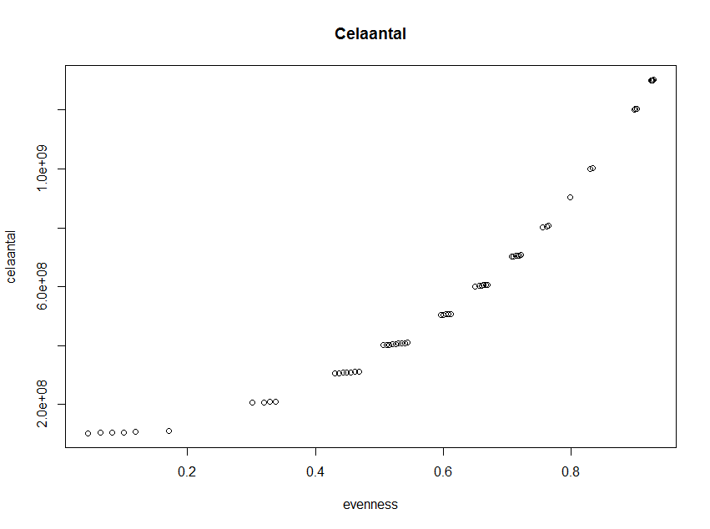

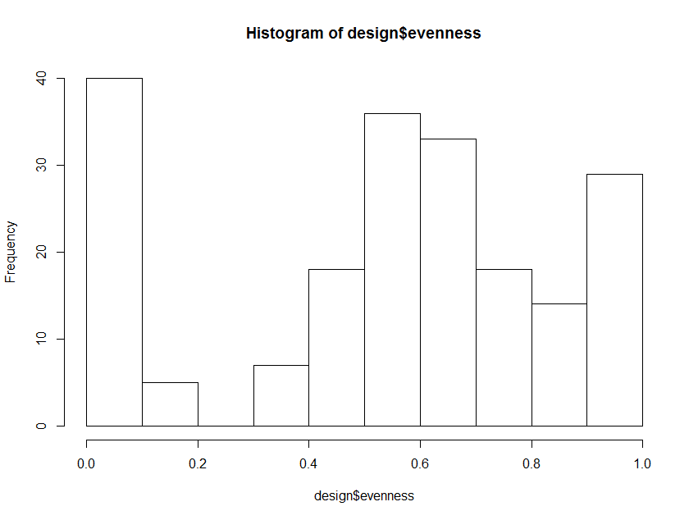

**Same principle as with 10 bacteria**

100 points randomly distributed

100 points according to a certain stratification: 40 low evenness, 40 high evenness, 20 around 0.5 evenness.

**pipetting example random evenness**



**pipetting example low evenness**



**pipetting example high evenness**



**Adapted design entirely random Elham for 16 bacteria**

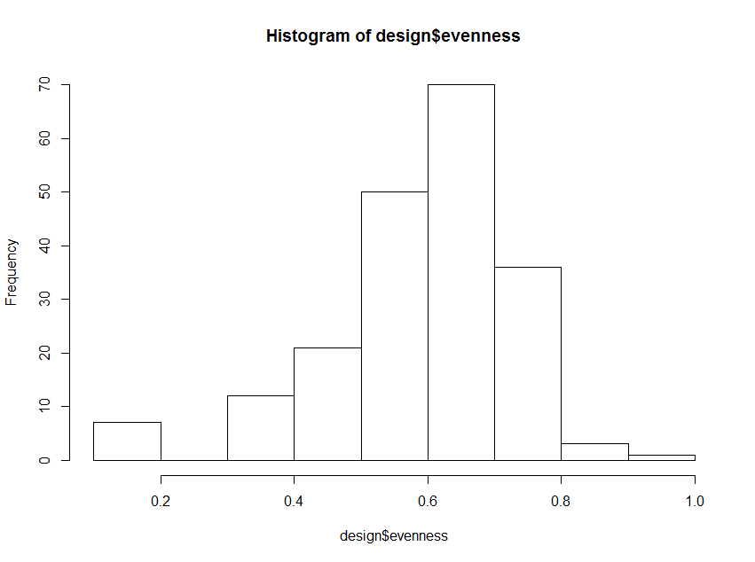

First 100 random samples exactly the same as 100 random samples in adapted design with stratification.

**Selected bacteria**

1) Pseudomonas sp. (10 TYP)

2) Bacillus sp. (1 Bacillus)

3) **Rhodococcus sp. (31 1R) => used one week old, since they are slow growers**

4) Serratia sp. (14.3 ISO1 4°)

5) Burkholderia Cepacia or Xenovorans ( 25.2 Burkholderia)

6) Acidivorax sp. (S9, K52)

7) Paracoccus sp. (42 Paracoccus)

8) Enterococcus sp. (59 Enterococcus)

9) Agrobacterium sp ( Beijirinckia)

10) Brachybacterium sp. (S51)

11) Ecoli or Shigella (32 Enterobacteria)

12) Rhizobium Duejenense (63 Rhizobium)

13) Delftia

14) **Micrococcus sp. (2 TYP) => used one week old, since they are slow growers**

15) Staphylococcus sp. (Staphylococcus)

16) Aeromonas sp. (K62)